**Project Report**

**Research Goal:**

Our research goal aims to compare prices of different seeds like crude palm oil (CPO) price, selected vegetable oil prices (such as soybean oil, coconut oil, and olive oil, rapeseed oil and sunflower oil), crude oil and the monthly exchange rate and the monthly exchange rates. As Malaysia has become one of the World’s leading pal oil producing country, their palm oil industries have grown vastly on local as well as global level. As a massive producer and exporter of palm oil and CPO products, Malaysia has an important role to fulfil edible oil and fat needs of the world. According to Malaysian Palm Oil Board (MPOB), Malaysia is the world’s second largest palm oil exporter after Indonesia and oil palm industry forms the economic backbone of Malaysia. As the world’s second biggest palm oil producer, Malaysia continues to face new challenges with volatile agricultural commodities prices especially CPO prices. The breadth of the palm oil industry and its significance cannot be understated as its impact ripples through the domestic as well as global economy. The Malaysian palm oil industry has undoubtedly made significant contribution towards the domestic economy as well as to the development of the world palm oil market. As fast growing edible oil playing a significant role in Asian economy, it is important to monitor and accurately forecast the price of CPO for the benefit of the Malaysian palm oil industry. Palm oil like any other agricultural commodities is subject to significant price fluctuation as shown in figure 1. The CPO price fluctuation passes on a significant risk to farmers, producers, traders, consumers and others involved in the production and marketing of CPO. An accurate CPO price forecasting technique is necessary to assist decision-making in risky and uncertain situations.

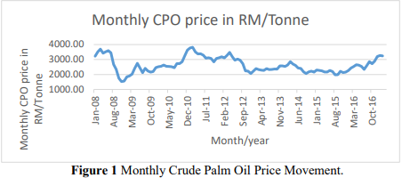

**Retrieving Data:**

Data collection and pre-processing of data are important tasks in data analysis. In this project nine time series data is used. The monthly closing price of all variables such as CPO price, sunflower oil price, olive oil price, rapeseed oil price, coconut oil price, peanut oil price, soybean oil price and West Texas Intermediate (WTI) crude oil spot price were retrieved from <http://www.indexmundi.com>. Monthly CPO prices, selected vegetable oil prices, crude oil prices and monthly exchange rate data from January 1987 to February 2017 were utilized.

**Data Preparation:**

Datasets that we acquired from indexmundi.com first need to have the Change column deleted as it was not required in our project. After removal of change columns from all datasets, second step was to merge the datasets, and after following these two steps, our final data was in clean shape.

**Data Exploration:**

Our dataset contains prices of CPO and other seed prices in terms of US Dollars per Metric Ton. First, we add mean of the respective column to the empty fields as there were fields which were empty and needed to be filled for processing. Then after, different datasets were merged into a single dataset to apply models on. Preliminary analysis showed a positive and high correlation between the CPO price and soy bean oil price and also between CPO price and crude oil price. Experiments were conducted using multi-layer perception, support vector regression, KNN and Random Forest techniques The results were assessed by using criteria of root mean square error (RMSE), means absolute error (MAE), means absolute percentage error (MAPE) and Direction of accuracy (DA). Among these three techniques, support vector regression(SVR) with Sequential minimal optimization (SMO) algorithm showed relatively better results compared to multi-layer perceptron and Holt Winters exponential smoothing method.